MSE110 Project 3 – Maze Solver
Group 6
Team Members:
- Ashton Cervantes: 301456702
- Jason Jang: 301476524
- Thanh Nam Tran: 301540228
Class: MSE110 D100
Semester: Summer 2022
Instructor: Dr. Ramtin Rakhsha
Date: August 5, 2022.

TABLE OF CONTENTS
ABSTRACT 3
Introduction 4
Features – What our project can do 4
Technical Constraints – What our project can’t do 7
Future Notes for Developers/Users 7
Conclusion 8

ABSTRACT

“A maze is a network of passages designed as a puzzle through which your robot has to navigate to the end. There is one path to the exit (or target square) and no loops. In other words, every possible branch dead-ends somewhere. Robot will start in a defined location and is done when it reaches the target. There are a few simple strategies and ways to program maze-following robots.”

With an EV3 Mindstorm lego set and RobotC editor, our team attempted to build a robot that solves a predetermined maze. The maze solver is built with an EV3 lego set, programmed in RobotC, and is able to navigate a maze from a selected start and end point using the right-hand-side algorithm and uses arrays to find the shortest possible path back to the start point. The maze is built using a grid of columns, rows, and functions that add walls and borders. The robot solves the maze in real life and on a screen.

Introduction
For this project we were tasked to build a robot using the EV3 Lego set that creates a maze that includes walls and borders as well as solves that maze from a start point all the way to an endpoint and reverses the process by going from the endpoint to the start point using the shortest path possible, all while being simulated at the same time on the EV3 screen. This will be done with algorithms and functions.

Features – What our project can do

- We declare variables for what we want our grid to look like. We chose a grid consisting of 4 rows and 6 columns. A later function uses these grids to simulate a maze on the screen of the EV3 but that will be talked about later.
- Using input variables we can use the integer “1” to create walls inside of the grid in certain cells/boxes on specific sides (north, east, south, & west).
- The robot keeps track of the direction it is going (north, east, south, & west).
- Able to set a starting position and set an endpoint for our robot
- Using the right-hand-side algorithm the robot makes a path to the endpoint from the start point.
- The right-hand-side algorithm solved the maze by first turning right to check for a wall in front of it, then the robot will turn left until it detects no wall in front and then it will move forward in that direction by a singular cell/box. It will turn right when entering the new cell/box
- How the robot moves in each cell is when it first moves into another cell it will ram directly into the front wall (if there is a front wall in that cell) and move back to correct any error in angles when it moved to that cell (if the robot is not facing directly at 0 degrees).
- After ramming into the front wall to correct its relative position in the cell, the robot will then turn and check for the right wall, front wall, and left wall respectively, and go 1 cell towards the direction in which there is no wall. (void function “MazeSolver” in the submitted code).
- When the robot reaches its endpoint it will beep and say “Maze Solved !!”.
- Then when the robot finally reaches the endpoint it will run an algorithm that uses the path it took from start to end and reduces any cells the robot went into the cell in different directions. The way this algorithm work is that using an array that contains all the steps it took to reach the endpoint it calculates to see if any cell during the path had a cell where the robot entered and exited in different directions (East vs West and North vs South). If a cell had the robot enter and exit in opposite directions, heading to the endpoint, those cells would be eliminated from the path heading back to the starting point. That is how we get the shortest possible path from the endpoint to the start point by using the path from start to endpoint.
- On the way back from the endpoint the way the robot moves in each cell is that if it enters a new and there is a wall directly in front of it then it will ram into that wall to adjust its positioning to make sure it is facing the correct way. If there is no wall in front then the robot will not ram into a wall. It will then turn 90 degrees to the right until it turns to the correct direction that leads to the next cell that the robot needs to go to, to reach the shortest possible path back to the start
- Not only does the robot solve the maze in real life but it also shows the whole maze and the robot solving the maze simultaneously as the actual robot on the screen of the EV3.
- On the EV3 screen it will simulate the robot going forward in whatever direction the robot heads when going to a new cell. The number of the row and column it is in will change based on if it switched to a different row or column.
- The screen simulation also keeps track of if the simulated robot were to turn left and right it also shows this and this lets the simulation know which direction the robot is facing.
- The screen simulation also shows when the robot turns 180 degrees and keeps track of this.
- This is not part of the screen simulation but the robot also keeps track of the degrees it turned because this is to make sure that the robot turns to the correct position that leads it to the proper path.
- We declare variables for the dimension of our screen that we want (height and width only)
- The screen simulation creates the grid with our inputted rows and columns by dividing the rows and columns by the height and width of our screen and that generates the grid we want that fits the EV3 screen.
- Another function builds the outer walls for the grid so the simulated robot can’t leave the maze. The way this function works is that it will create walls on the edges of the outer boxes as long as some incrementing variables are less than the total number of rows and the total number of columns.
- The screen simulation also creates a robot on the screen that acts as the actual robot that is moving in real life.

Technical Constraints – What our project can’t do
This project is designed and built tailored to the specific features/requirements above. Therefore, the number of tasks this project can’t perform is essentially unlimited. The list below attempts to highlight a few significant ones:
- Not able to use the left-hand-side algorithm to solve the maze
- Not able to turn in a precise direction (turn a little more or a little less to the left/right than we want it to)
- Not able to turn to the left on the shortest path back to the start.
- Not able to turn in increments less than or greater than 90 degrees.

Future Notes for Developers/Users

For potential users:
This project is an early form of AI robotic navigation. A fully implemented maze-solving bot could have many practical applications:
- Military search and rescue operations.
- Speleology(basically cave exploration). A robot that can solve a maze or find its way out again, could map the cave, take samples, etc if the cave is either too small or too dangerous for humans.
- Intelligent traffic control that helps ambulances, firefighters, or rescuing robots to find the shortest path to their destination.

For future developers:
- It would be a good idea to somehow fix the turning problem and make each turn as precise as possible. Also, a feature that could be implemented is that it should be able to turn in angles that are multiples of 90 degrees like 180°, 270°, 360°, etc.. instead of just 90°
- Make it so that the robot takes the shortest possible path going both ways, instead of just being the shortest path back to the start. The right/left-hand-side algorithms are helpful but they take too long and have unnecessary steps.
- On the shortest path back to the start the robot should be able to turn left and right instead of just turning to the right.

Conclusion
In this project we built a robot using the EV3 Mindstorm brick to solve a provided maze using sensors and the “right-hand-side” algorithm we navigated the maze from determined start coordinates and end coordinates. The robot then returned to the starting coordinates by calculating the shortest possible path by using arrays. While the robot is solving the maze in real life a generated version of the 4x6 maze is created with the same walls and borders as the real-life counterpart in the code of RobotC. Using this simulated maze our robot was also simulated into the grid and solved the maze in the simulation at the same time as the real-life robot. The simulation is then shown on the screen of the EV3 brick as the real robot is solving the actual maze. This report also talks about what our project can do currently, some technical restraints we encountered, and some notes so people can improve our current model in the future. This project was definitely a challenge for our team but we also found it quite enjoyable to solve many of the problems we encountered.

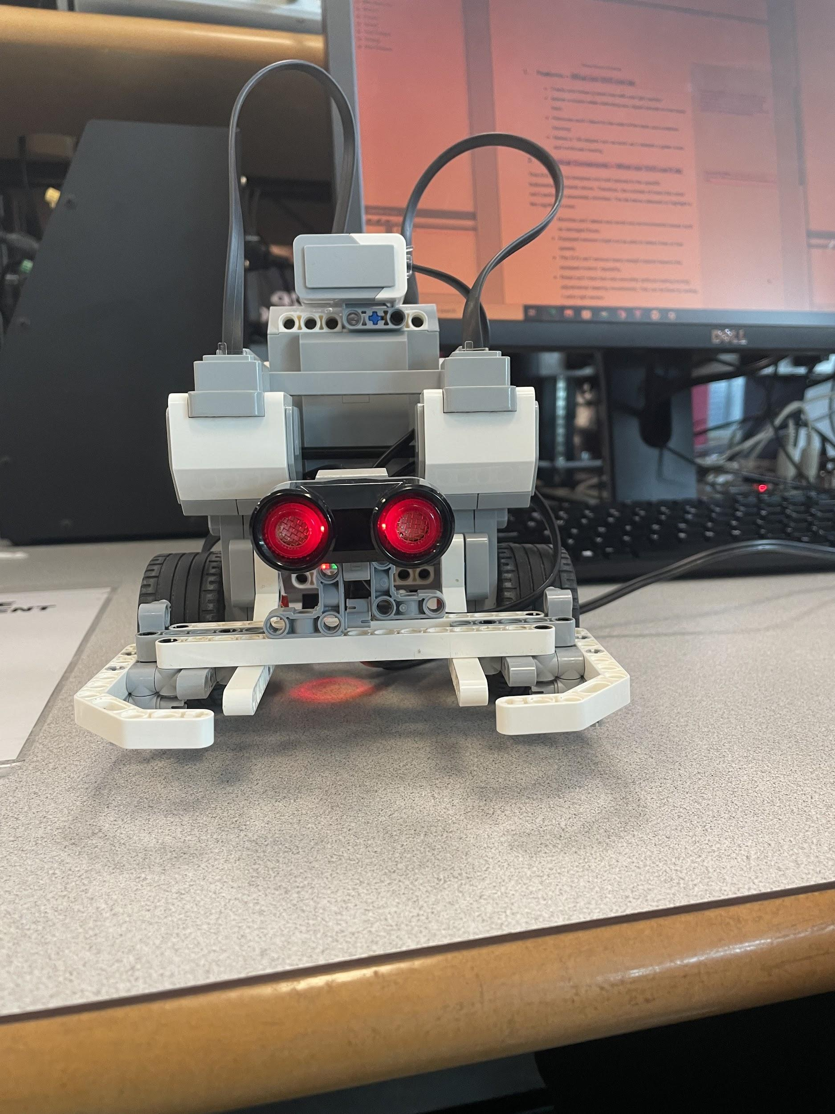
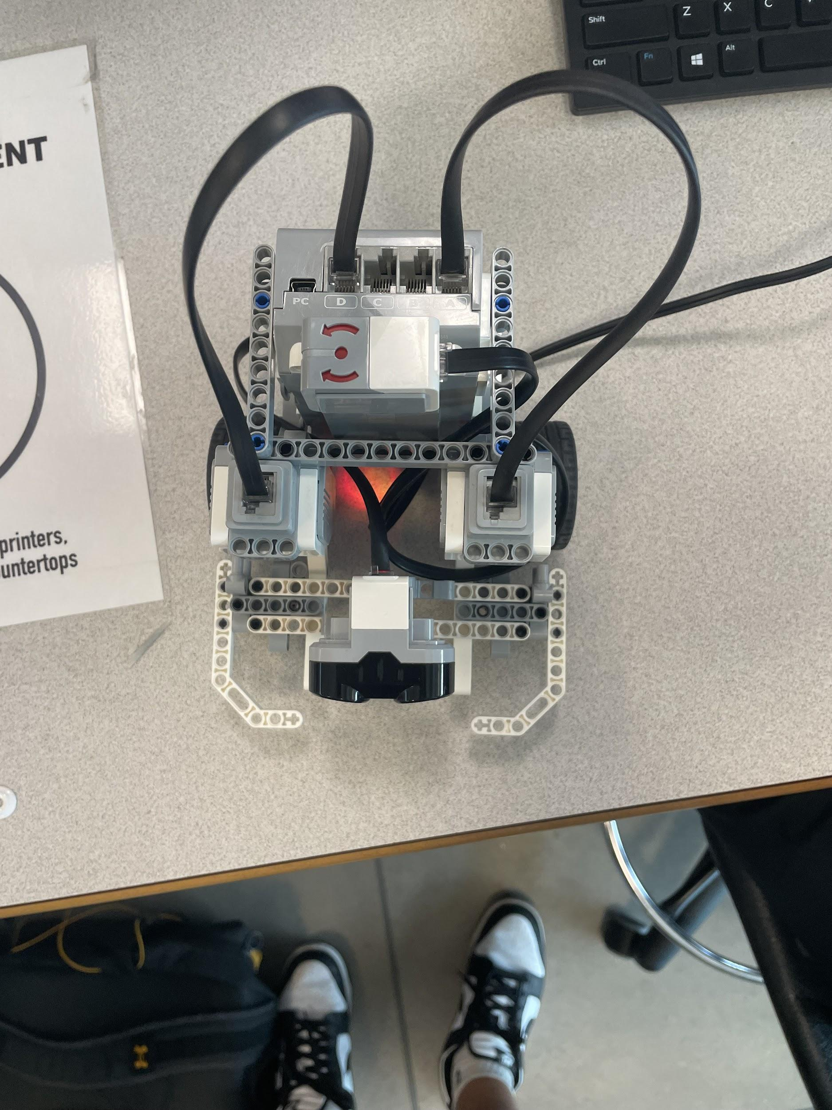
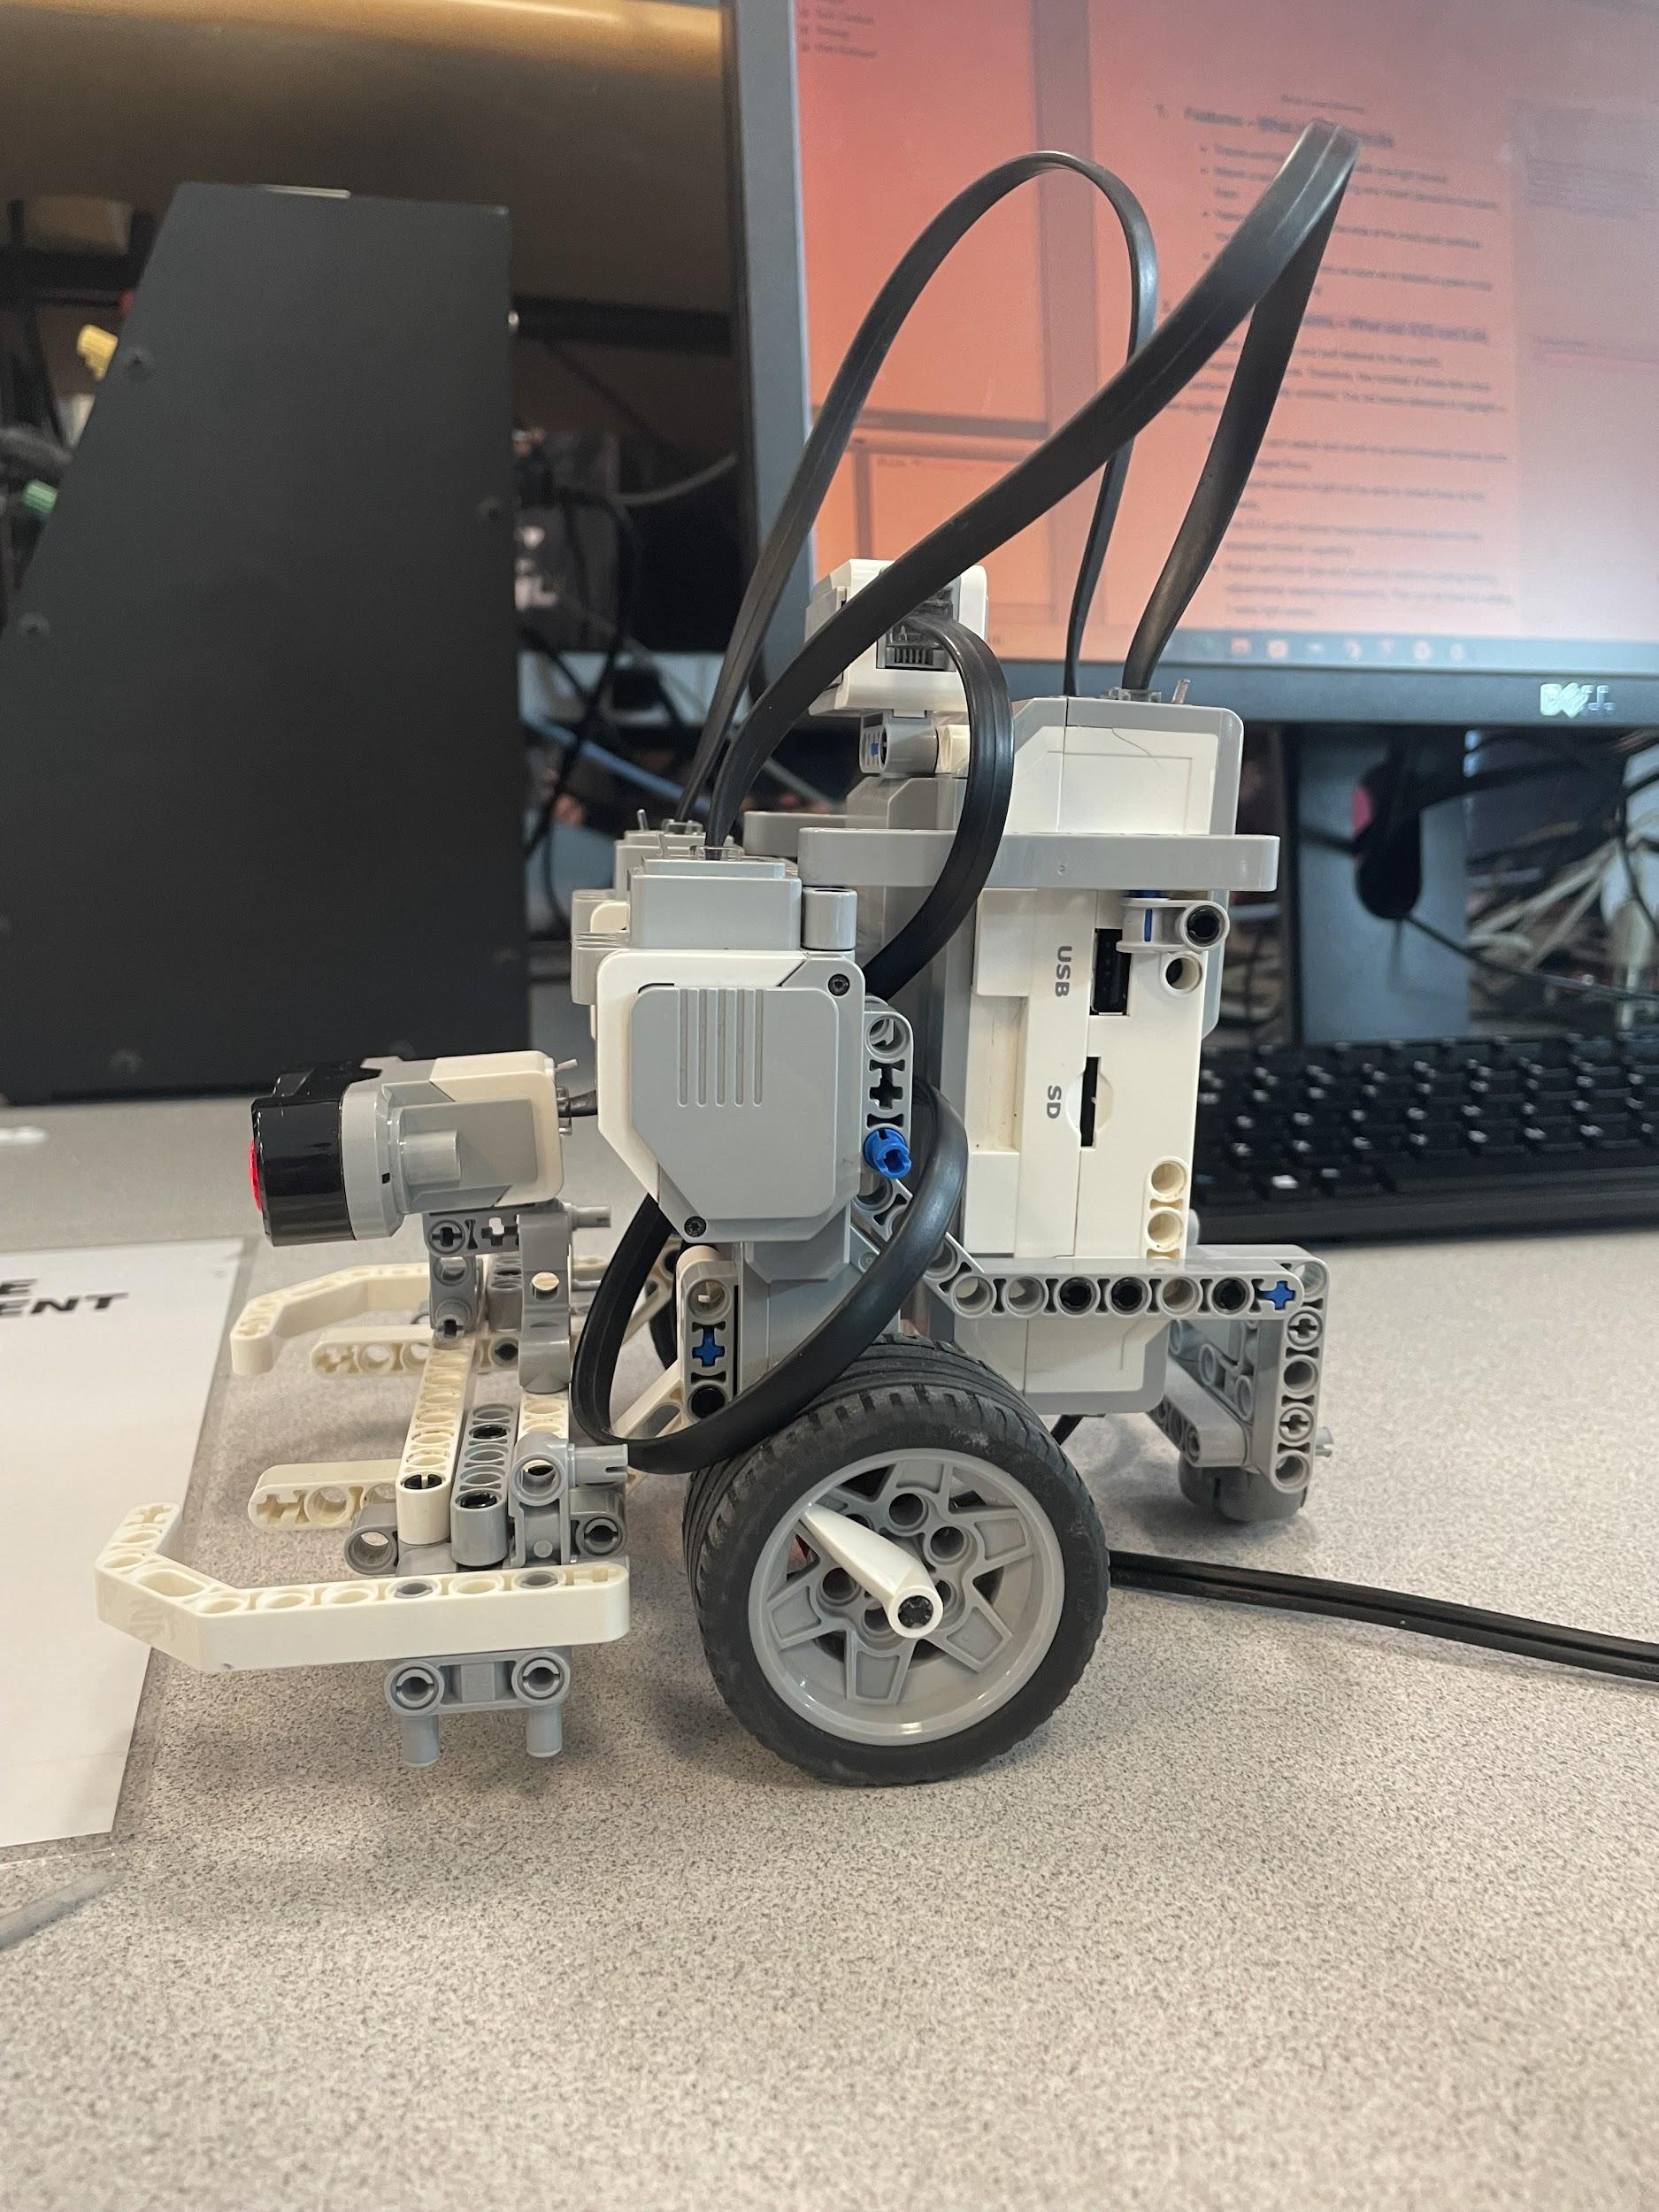
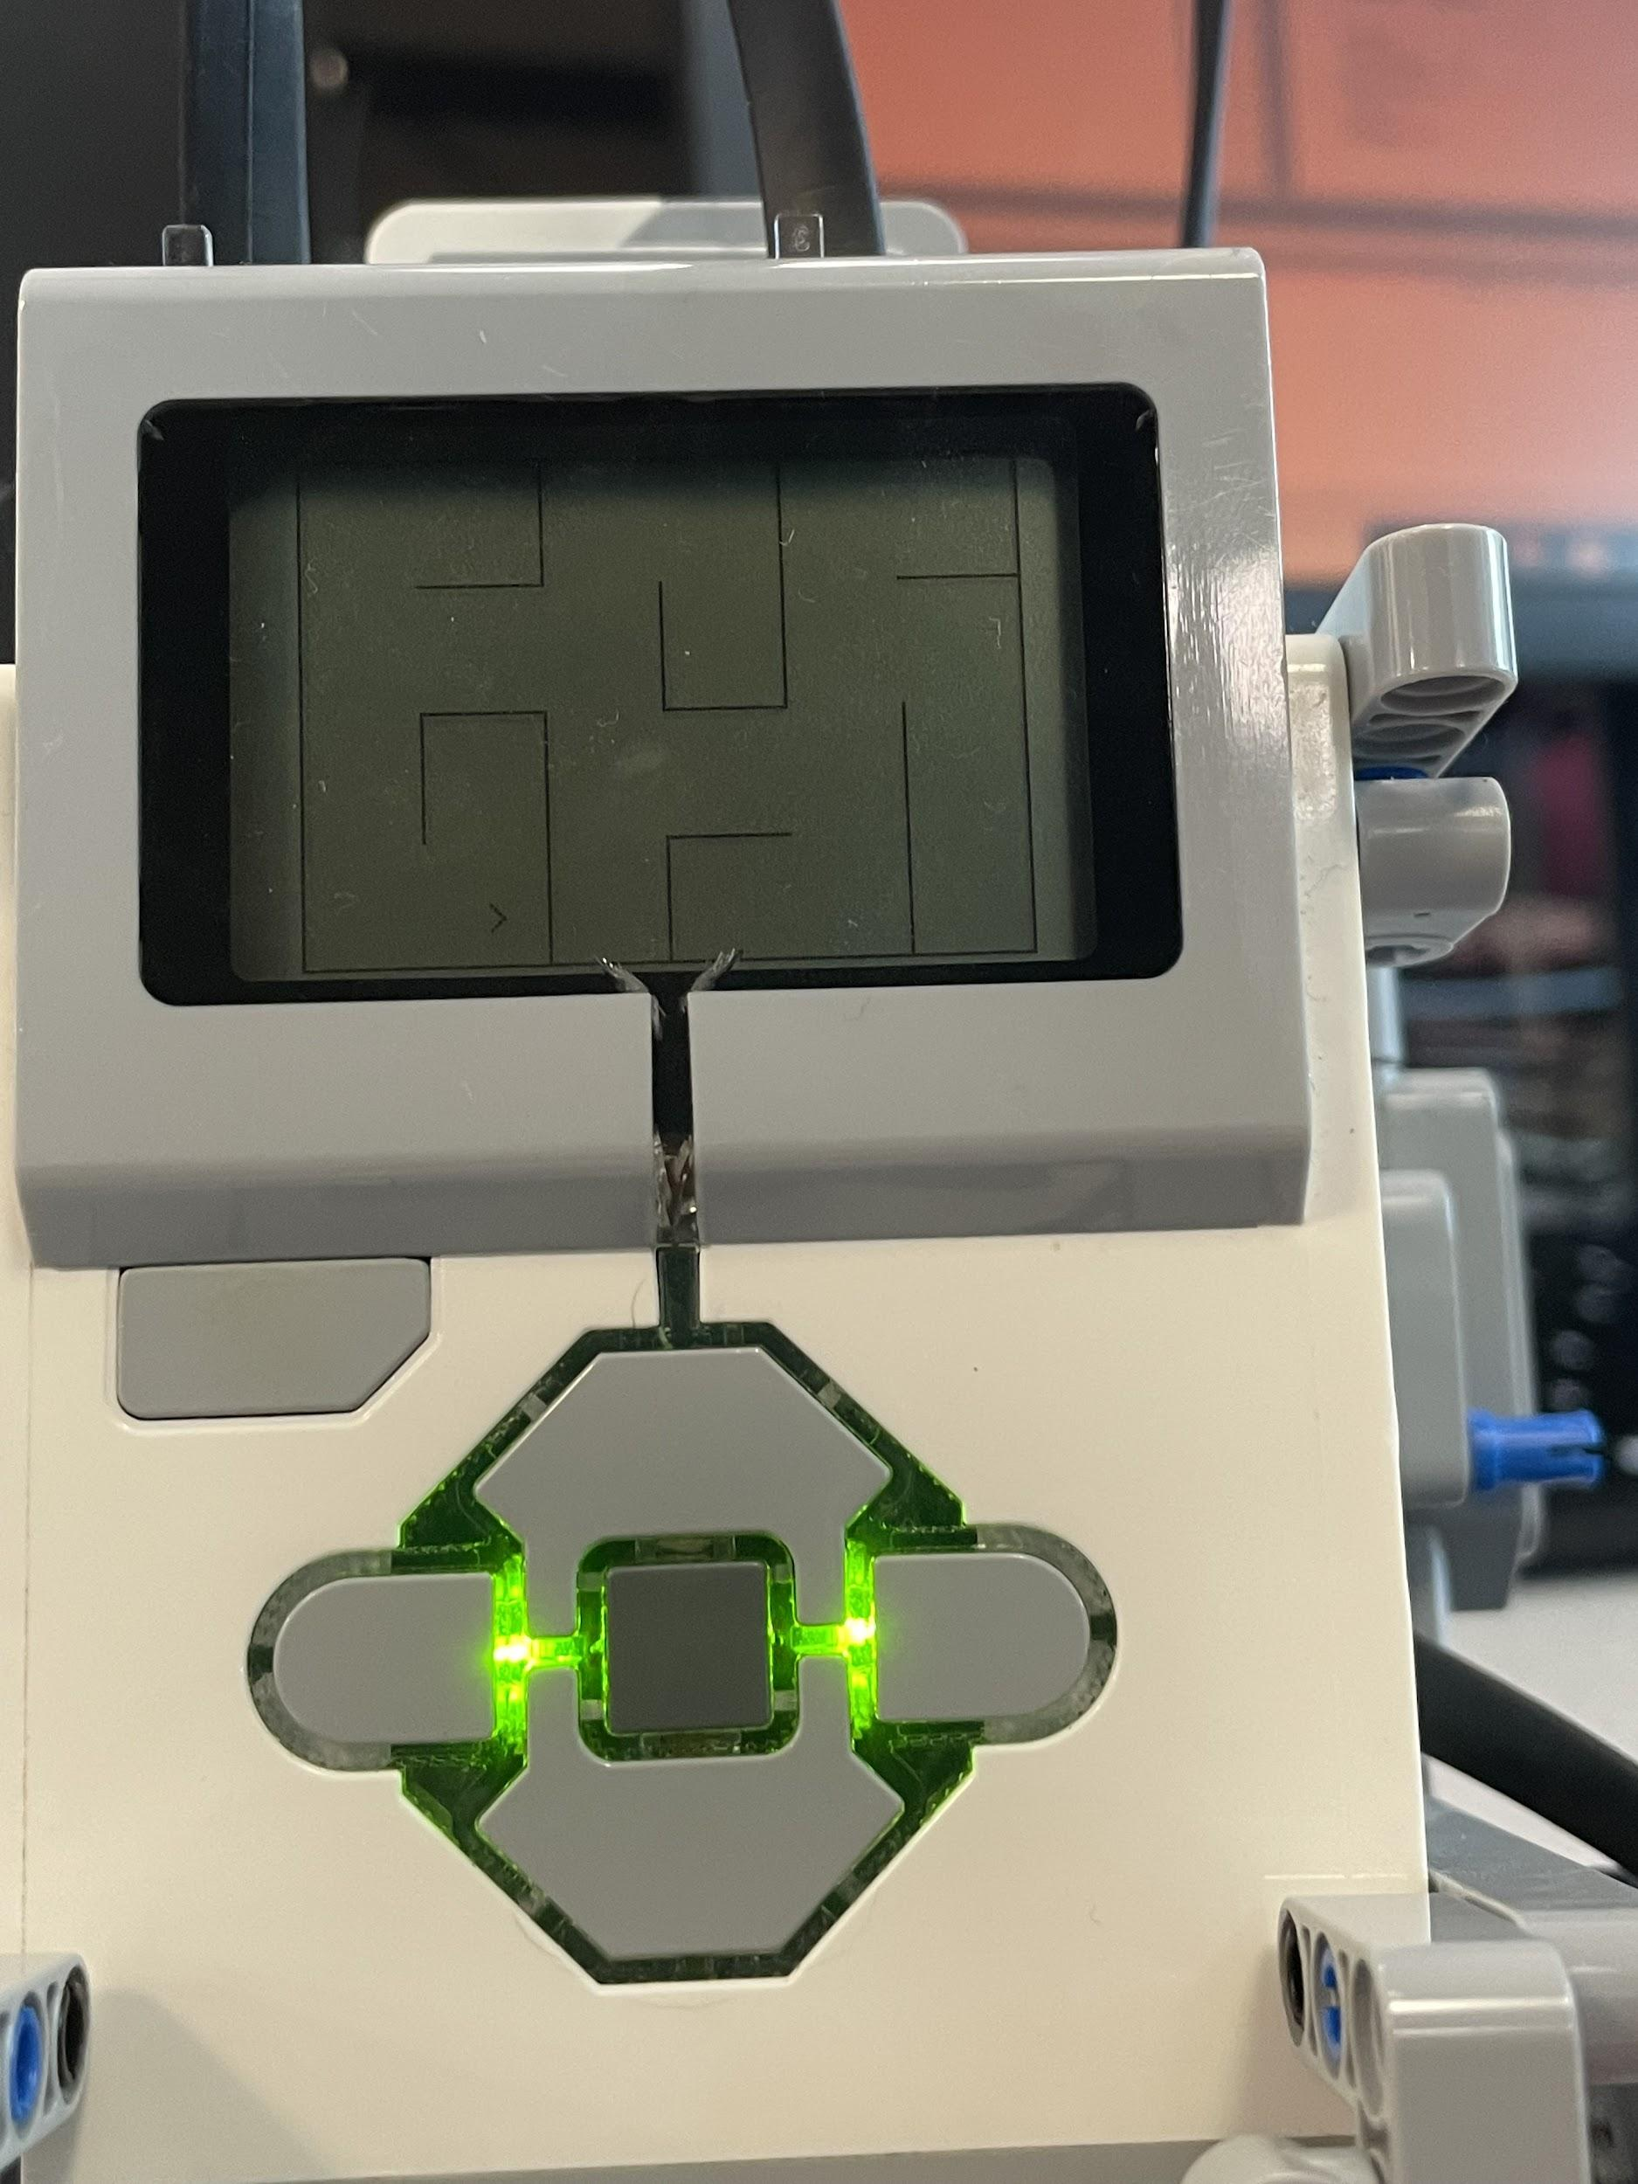
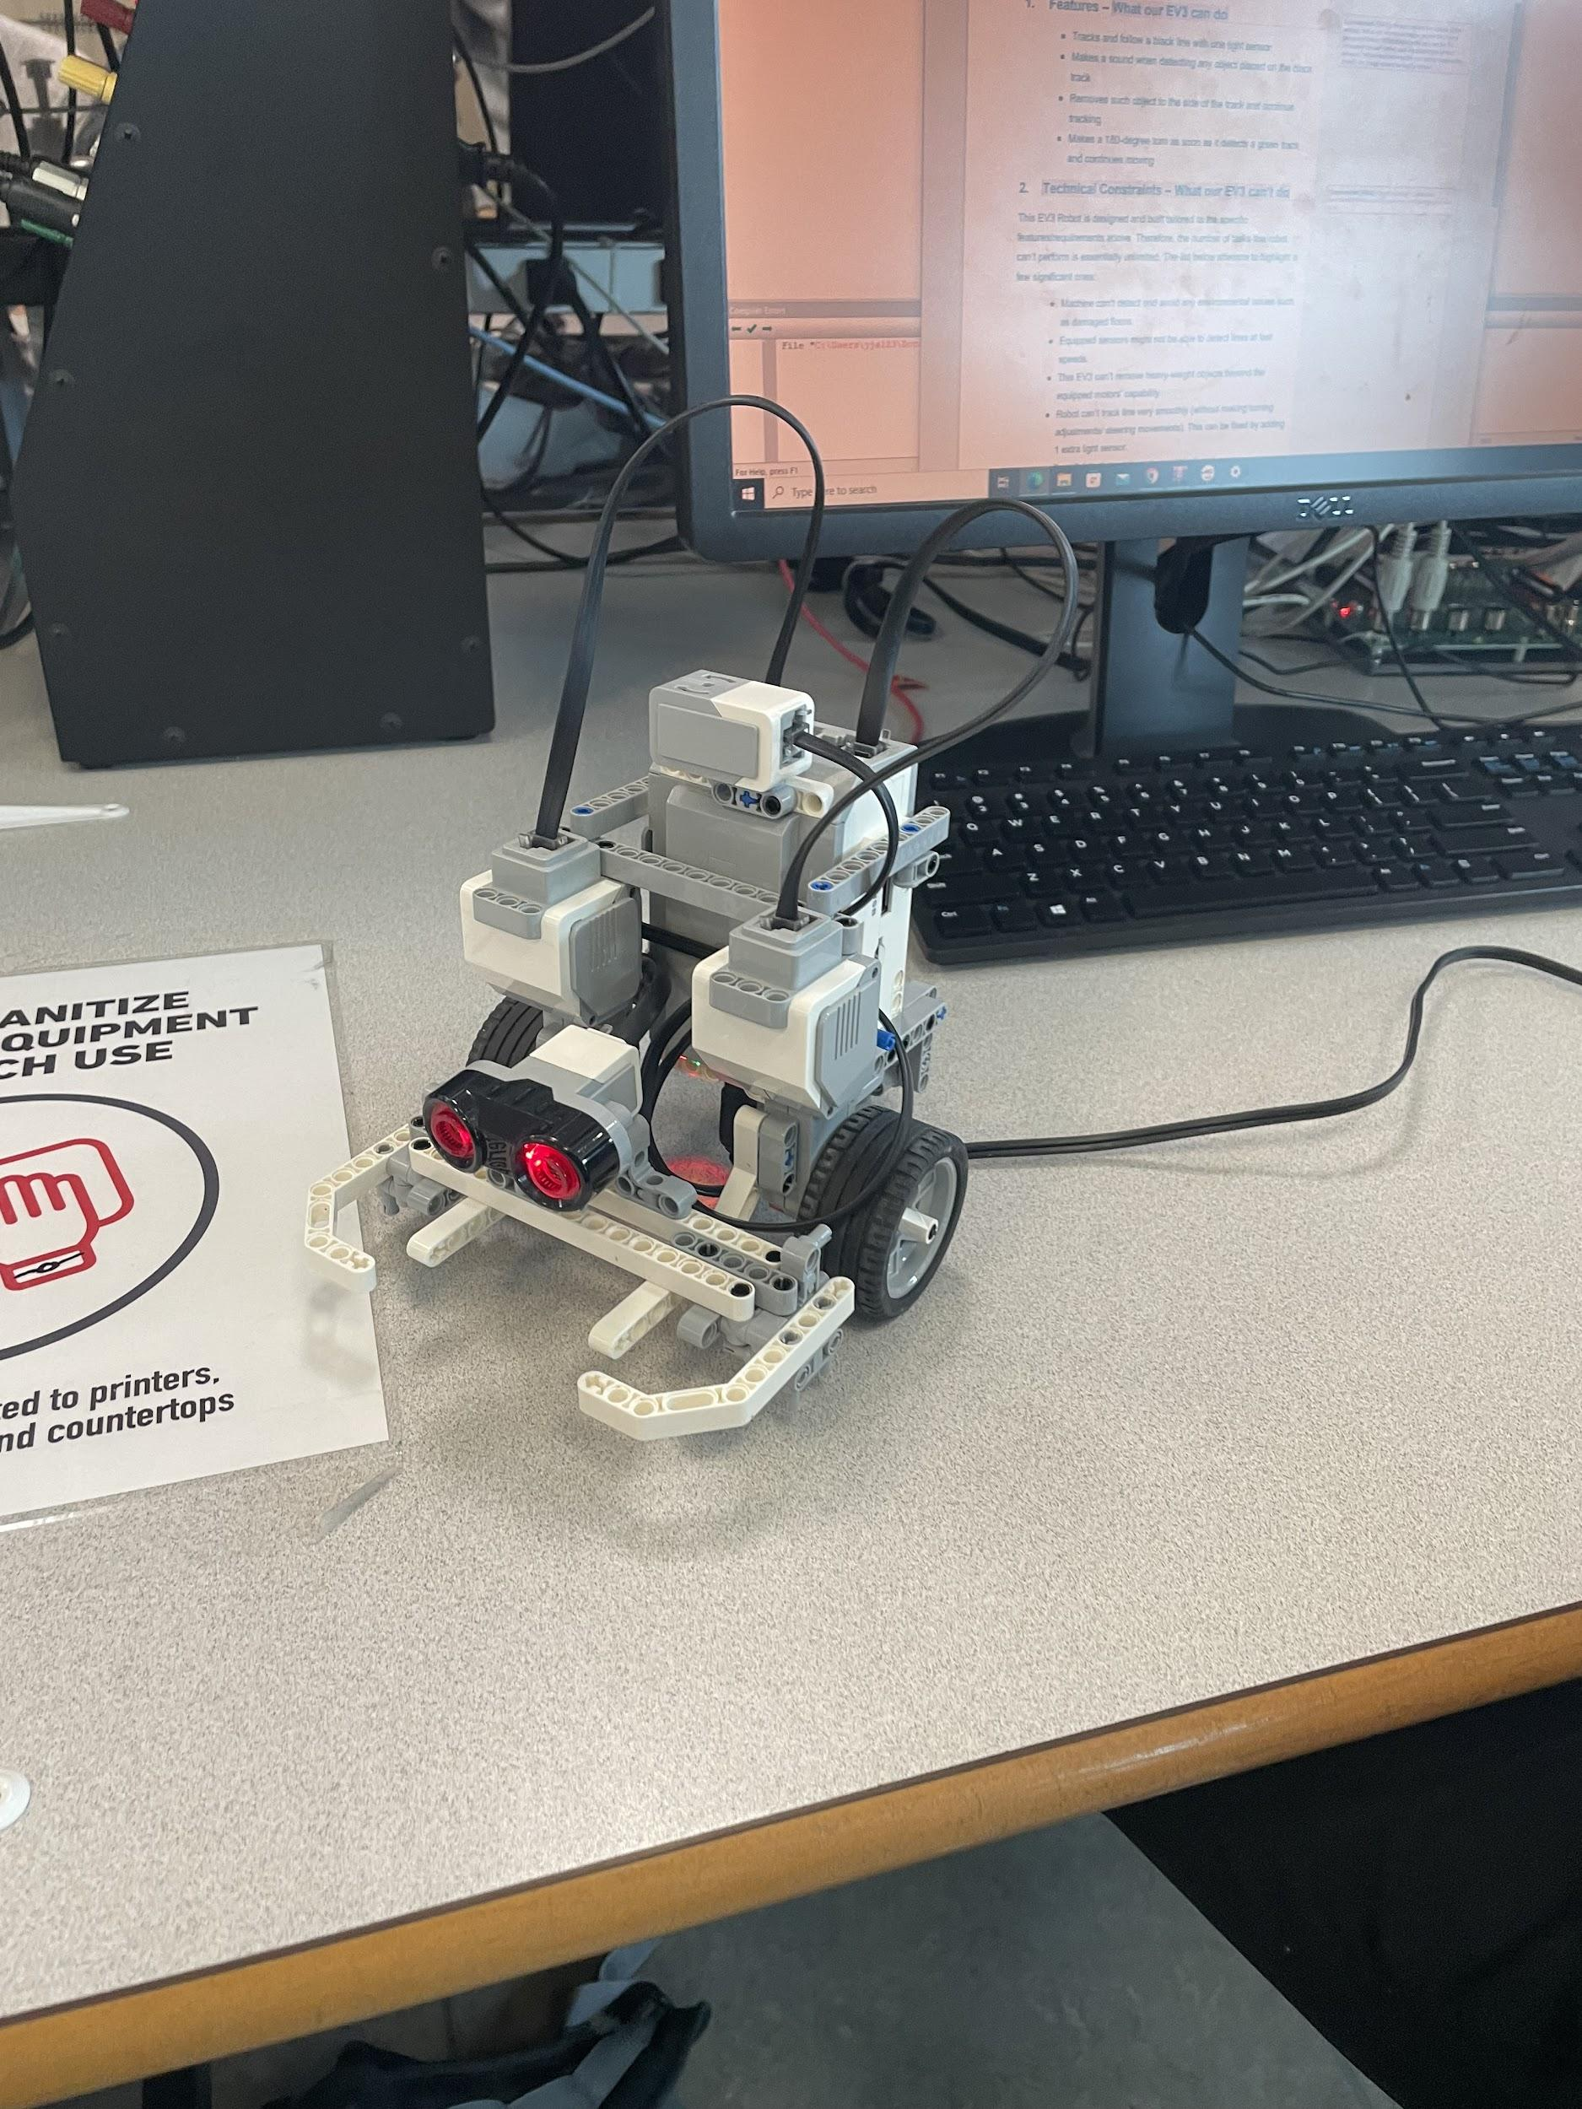

https://docs.robotmesh.com/amazing_mazes

